**Wireframe Document**

**Data Visualization of Bird Strikes between 2000-2011**

# Document Control

|  |  |  |  |  |
| --- | --- | --- | --- | --- |
| **Date** |  | **Version** | **Description** | **Author** |
| 04/11/2022 | 1.0 |  | Introduction,  Problem Statement | Khushi |
| 20/11/2022 | 1.1 |  | Dataset Information,  Architecture  Description | Khushi |
| 22/11/2022 | 1.2 |  | Final Revision | Khushi |
|  |  |  |  |  |

**We Performed Exploratory Data Analysis on Jupyter Notebook and then created a Power BI Desktop Dashboard.**

**1. Total number of Bird Strikes Incidents between 2000-2011**

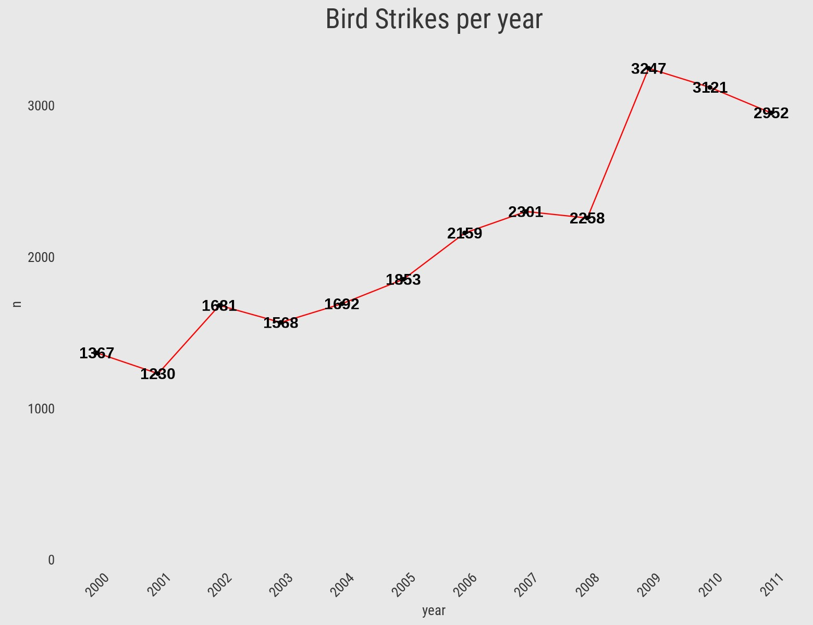

* **We can see that the incidents have an upward trend.**

* **2009 has the highest no. of bird strike incidents**

**2 Top 10 Airlines having highest number of bird count encounters**

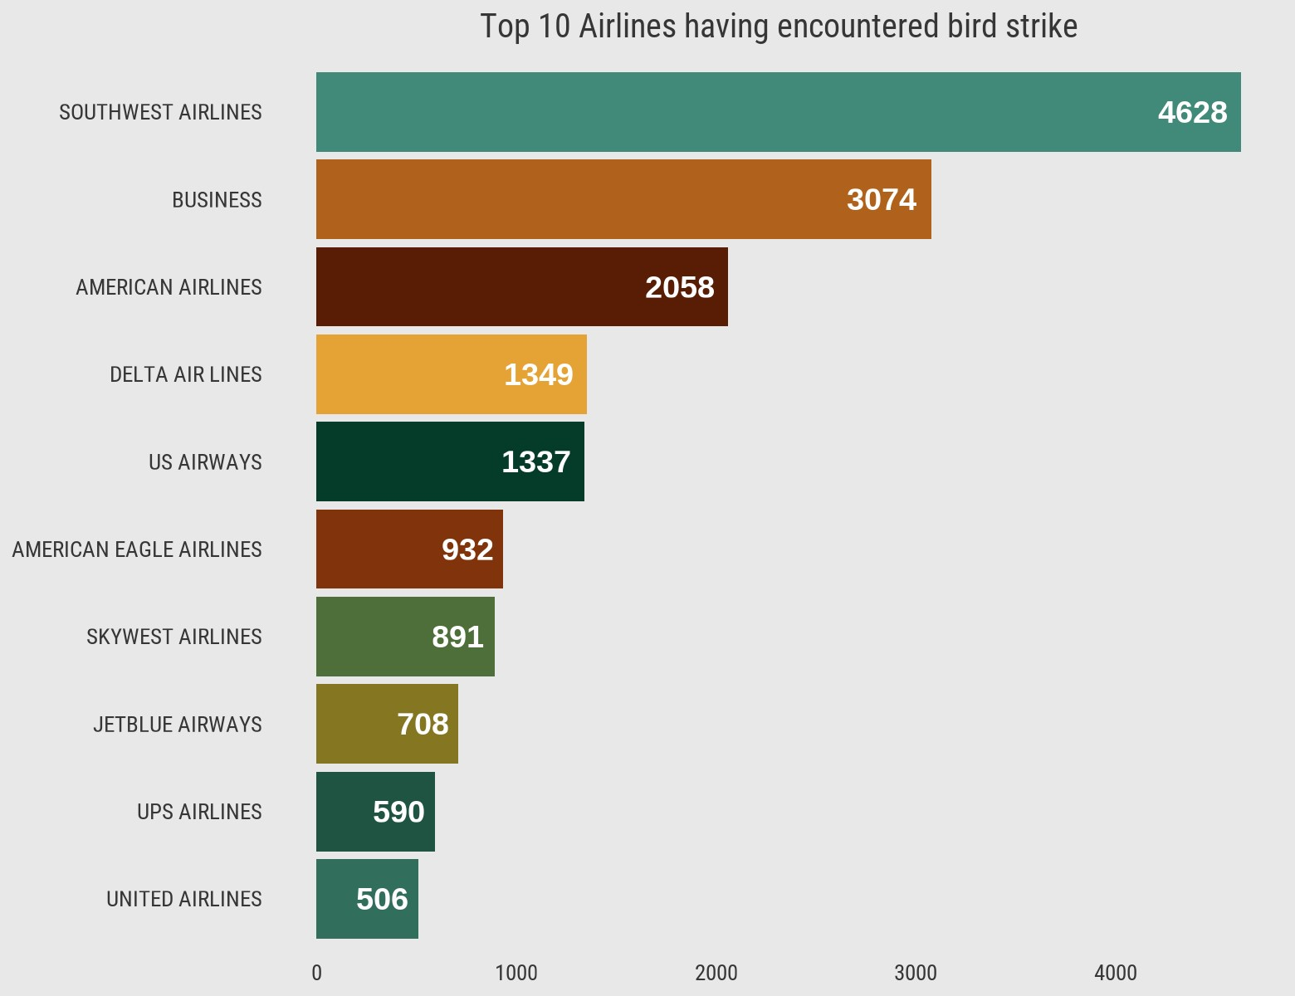

• **Southwest airlines followed by business and American Airlines have high number of bird strike incidents**.

**3. When do most bird strike occur?**

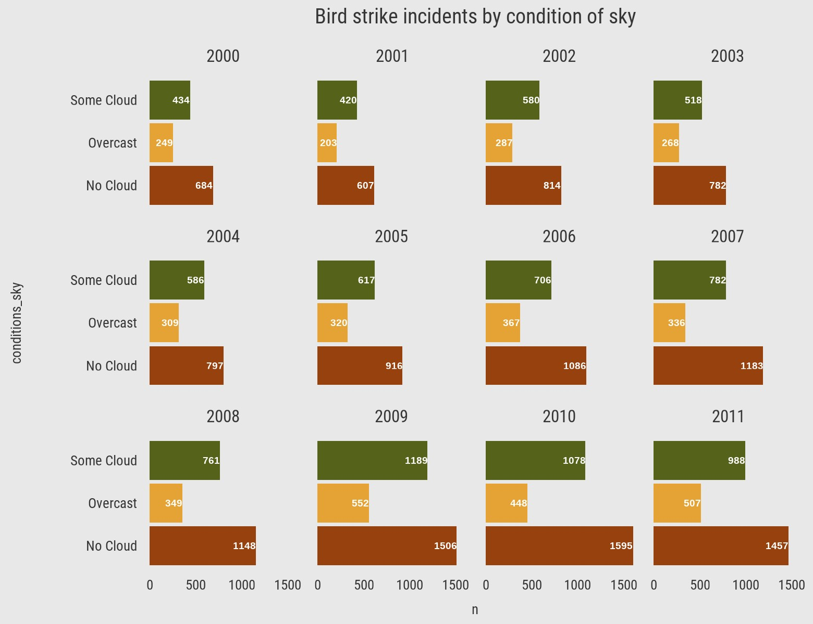

• **Most of the bird strike incidents happened during ‘No Cloud’ Sky conditions**.

**4. Altitude of Airplanes**

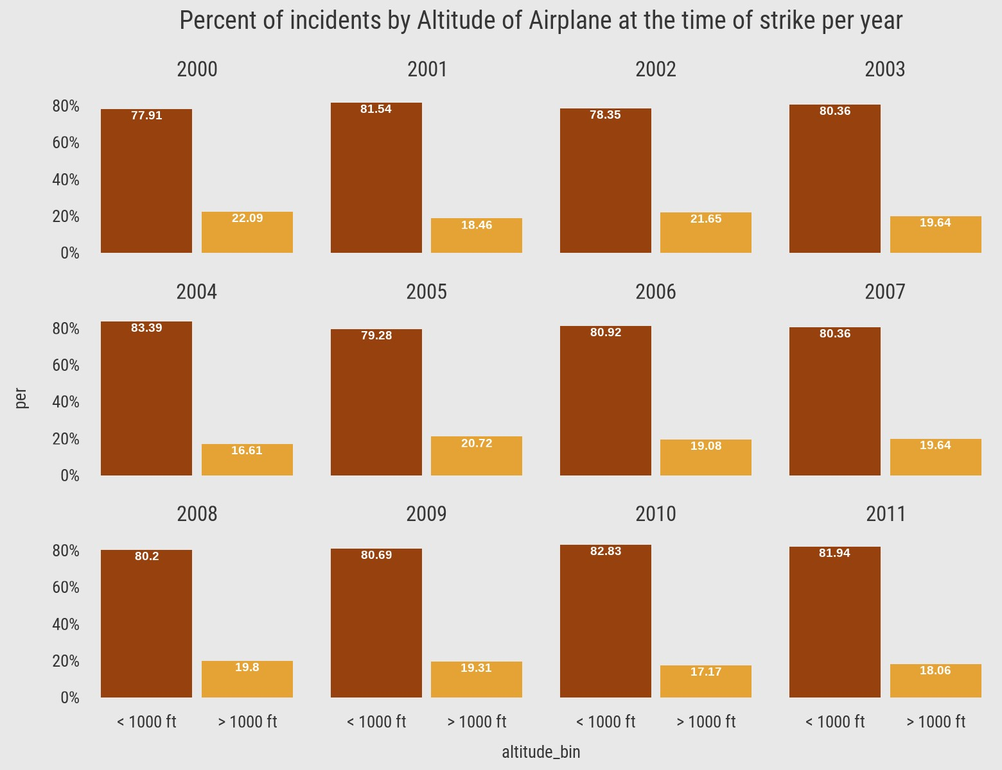

• **Nearly 80 percent of bird strike incidents happened when the altitude of the airplane was <1000 ft**.